New Boxcryptor Enterprise Plan with Single Sign-on and More Enterprise Features
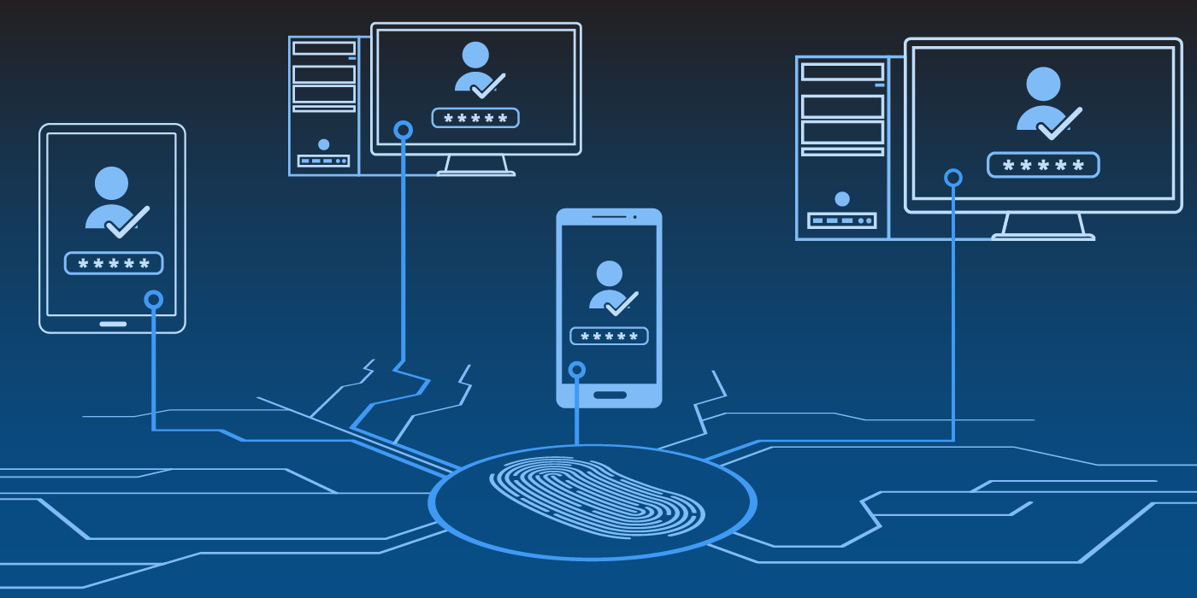
Boxcryptor Enterprise is a newly introduced plan of the German cloud encryption solution. The prime feature of this new plan for 50+ users is Single Sign-on (SSO), which makes user management for large companies much easier and reduces risk of human error, when handling sensitive data. Boxcryptor is the first zero knowledge cloud encryption software on the market that offers native SSO.
Augsburg, 09/26/2017: With the introduction of the new Enterprise plan, the German security firm Secomba reacts to the need of larger organizations for premium support and for the simple handling of setup and user management. Features of the Enterprise plan therefore include – apart from Single Sign-on – account capture, premium email and phone support, personal setup assistance, customer-managed keys as well as having an own dedicated account manager at one’s disposal (Find more information on the new features here).
The key feature of the new Enterprise plan, however, is SSO. Making the cloud encryption solution Boxcryptor SSO-ready was a challenge for the team at Secomba for two reasons: first, because Boxcryptor is an encryption solution and second, because the company is very keen on upholding their high privacy and security standards. Standard SSO protocols only handle user authentication, but Boxcryptor also needs zero knowledge key management for decrypting and encrypting data. Therefore, a whole new method to handle encryption keys and operations had to be developed.
How the Boxcryptor team implemented SSO is documented in the technical SSO presentation, attached to this press release. All SAML-based SSO solutions are supported, including industry-leading Microsoft Azure Active Directory (AD), Active Directory Federation Services (ADFS), Okta, PingIdentity, OneLogin and many more.
Robert Freudenreich, CTO and co-founder of Secomba about SSO and Boxcryptor Enterprise:
“The number of our customers is growing steadily and quickly and with it, the size of the businesses protecting their cloud with Boxcryptor. One important requirement for those larger organizations is to be able to quickly and simply add and manage their users. We are very proud that we managed to create an SSO solution that can handle encryption and security operations while staying zero knowledge. Even with SSO, access to a company’s data is strictly limited to the customer, locking out the cloud provider as well as us.”
Boxcryptor is an encryption solution for cloud storages, such as Dropbox, Google Drive or OneDrive, and is available on all major platforms. It is optimized for team work and gives users and organizations full control over your data thanks to AES-265 and RSA end-to-end encryption with zero knowledge standard. Secomba’s headquarters and servers are located in Germany. The latter are ISO and IEC-certified (ISO/IEC 27001:2013).
From now on, Boxcryptor is available for teams as Boxcryptor Company or Boxcryptor Enterprise, depending on the needs of each individual organization. No matter which plan an organization chooses, corporate privacy and compliance to privacy regulations are moved to the next level while keeping user-friendliness and ease-of-use.

More information and material: https://www.dropbox.com/sh/me1o2h08cwmoyam/AACArgIp6A343vE0Ow-YHkzza?dl=0

Your contact person for any questions:
Secomba GmbH
Rebecca Sommer tel: +49 (0821) 907 861 50
Werner-von-Siemens-Str. 6 fax: +49 (0821) 907 861 59
86159 Augsburg mail: rs@secomba.com
www.boxcryptor.com
Secomba GmbH – founded in 2011 and located in Augsburg, Germany – is the developer of Boxcryptor, a cloud-optimized encryption solution with more than 40.000 satisfied customers worldwide. In 2014, Secomba received the German Founder Award in the category “startup”. In 2012, the German Telekom honored the company with the second place at the Telekom Innovation Award.

